1. What are the different margins options and do we adjust the margins of the excel worksheet?

Ans : There are three margin options by default i.e., Normal, Wide and Narrow. Apart from this we can adjust margins by setting the value of left, right, top and bottom margins according to requirements under page setup option in the page layout ribbon.

To adjust the margins of an Excel worksheet, you can follow these steps:

1. Go to the Page Layout tab
2. Click on the Margins dropdown in the Page Setup group.
3. Choose one of the predefined margin options (such as "Normal," "Wide," or "Narrow"), or click on "Custom Margins" to specify your own margin values.
4. If you choose "Custom Margins," a dialog box will appear where you can enter specific margin values for each side (top, bottom, left, and right), as well as header and footer margins.
5. Enter the desired margin values and click "OK" to apply the changes.
6. Set a background for your table created.

Ans : we can use background option under page layout ribbon and choose the images either from device, drive or search online images.

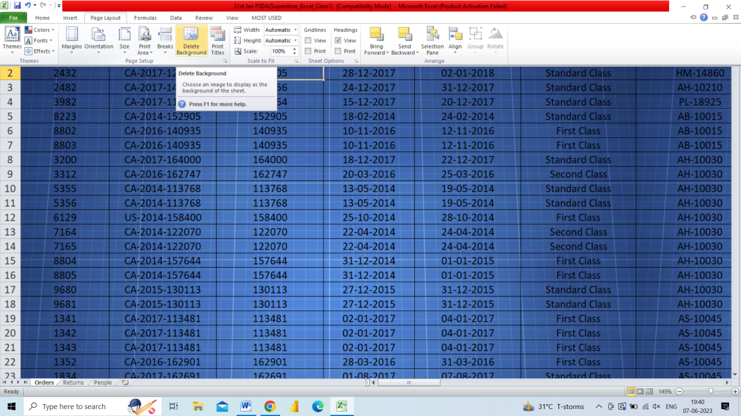

1. What is freeze panes and why do we use freeze panes? Give examples.

Ans : A excel sheet contains a large set of data in which there can be a number of column containing headers that we have to keep our eyes on and there is a chance that we can lose or forget the columns features so to avoid that circumstances we have to fixed the rows/columns to properly get the records and these can be done by activating freeze panes option found under window ribbon control of the view ribbon.

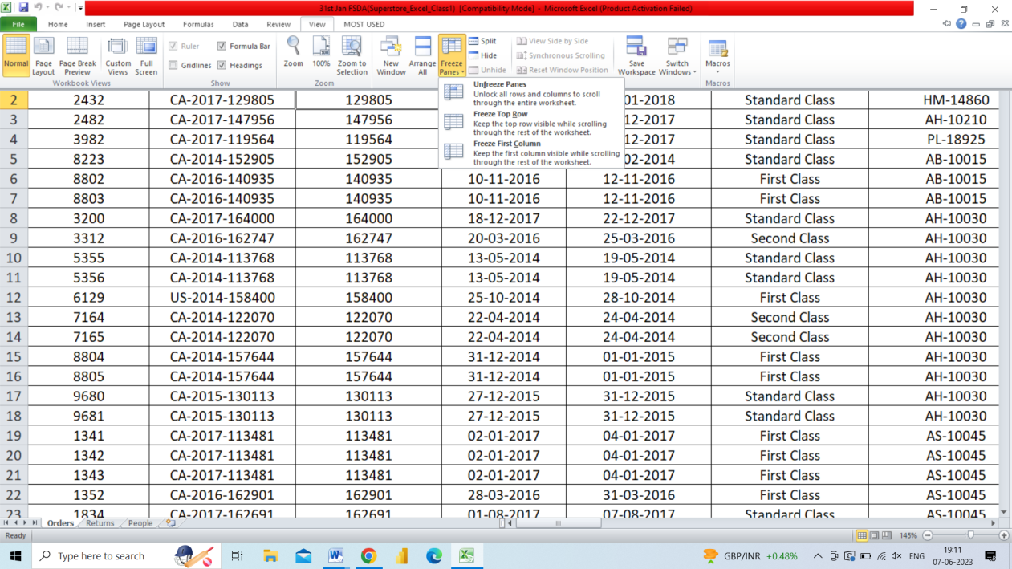

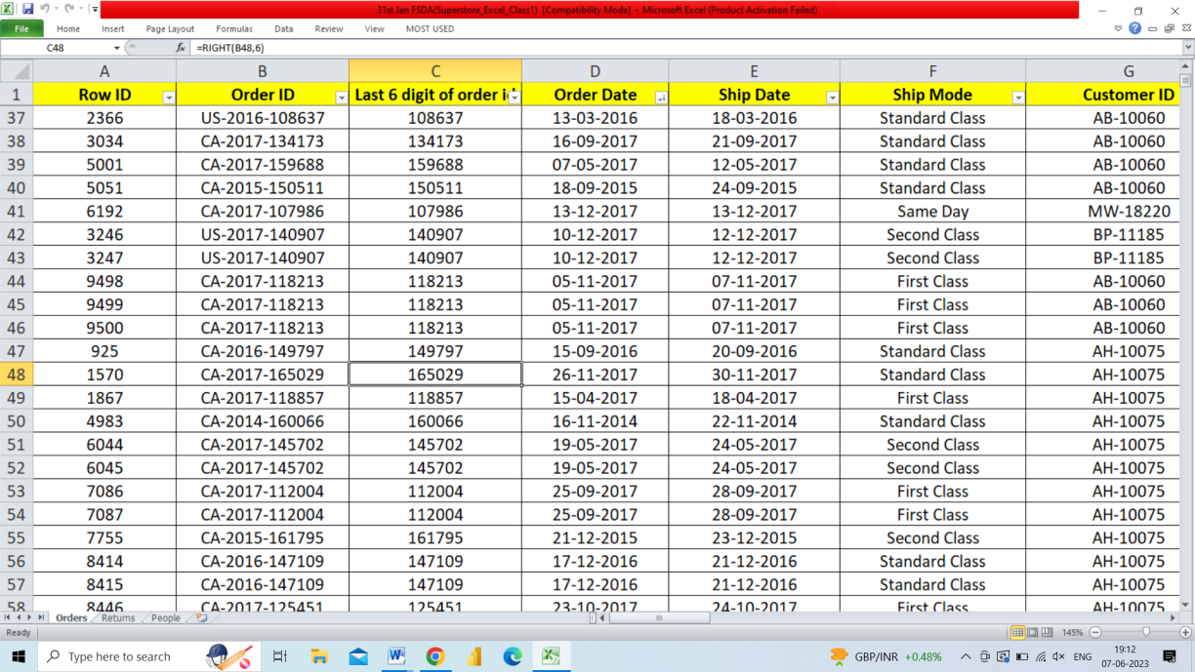

1. What are the different features available within the Freeze Panes command?

Ans: There are three options in the “Freeze Panes” option

1. freeze/unfreeze panes
2. freeze top row
3. freeze first column.
4. Explain what the different sheet options present in excel are and what they do?

Ans : Mainly three options/views are available in excel for sheets i.e., Normal view, Page Layout view and Page Break Preview.

* + Normal view is a default view in excel it is quite clean and easy to work on views in an excel.
  + Page Layout View provides the start and end of page with headers/footers options and have visible background if applied in the sheet.
  + Page Break Preview facilitates a clear picture of the sheets and what is going to be print in which pages. It gives the page break points, page number and blackout the non-containing/empty cells.